# TC 303803-Flag Comparison

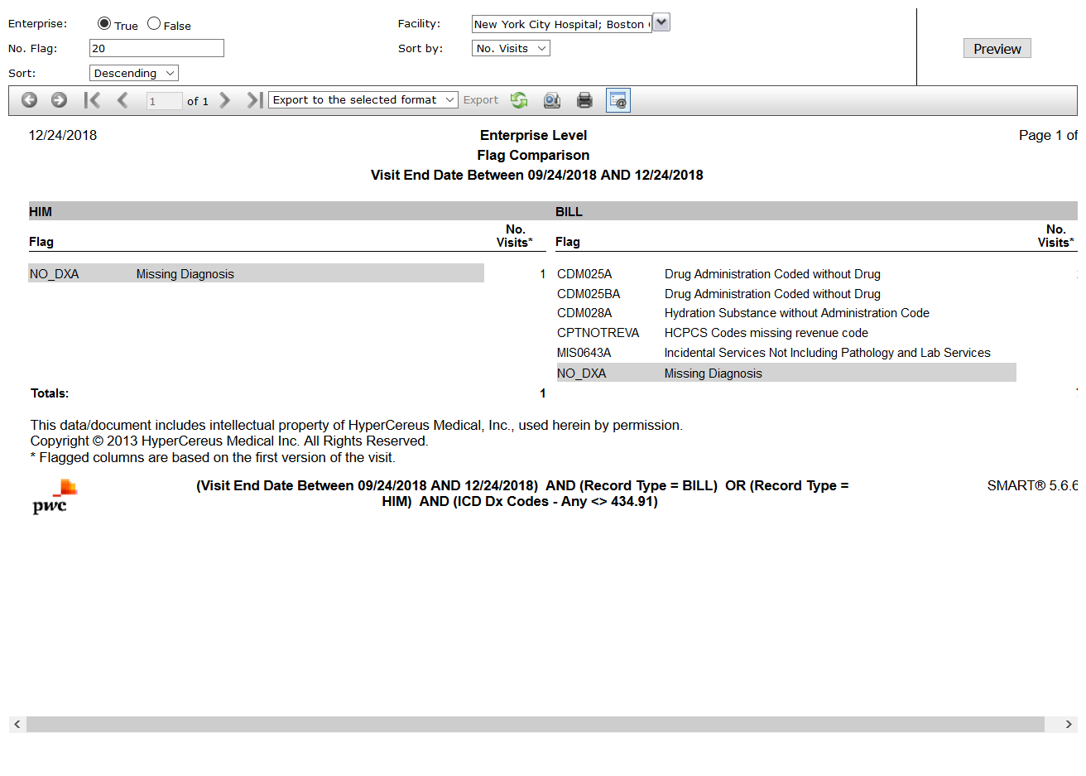

# TC 303806-Medicare Medical Necessity Flags

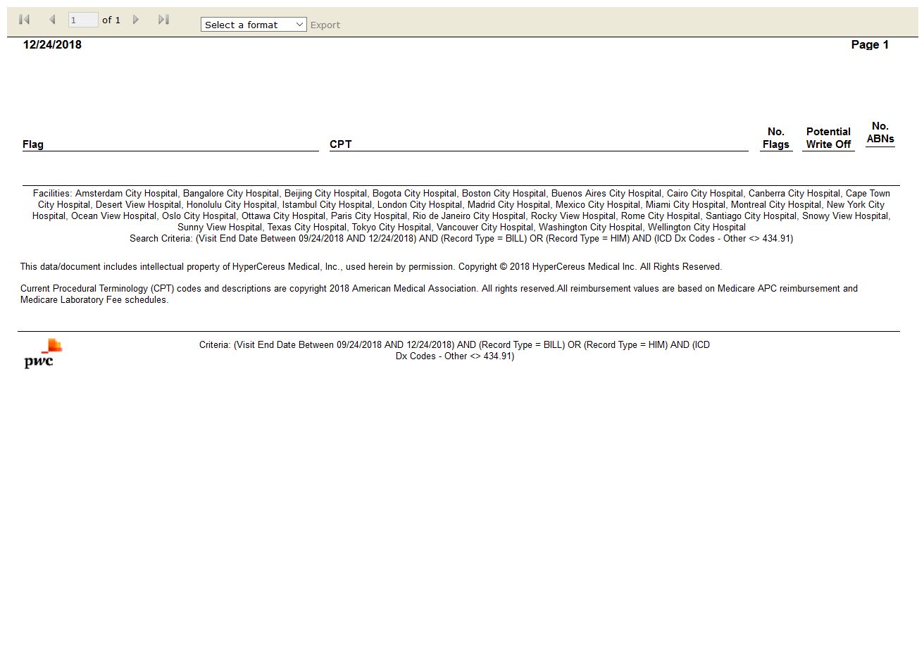

# TC 303803-Flag Comparison

